PMG201c
Online Learning Management System
Name - Shortcut

Note:
- Green: Already had in the previous Exam (2024).
- Orange: Have not been in the previous Exam yet (2024), but has in the Coursera Exercise.
- Blue: Solution
- Other questions: Normal questions or many exams.
- Bonus: We already studied in Chi’s lesson but have not in the previous Exams.

Introduction
- Exercise (SP24, SP24-RT, SU24, SU24-RT): Give detailed descriptions for the project in which you mention clearly its key characteristics: project title, project purpose/objectives (unique), project timeframe (temporary), customer/sponsor (clearly defined), project milestones (time constraints), and other project constraints (cost, resources), Success criteria, Project Deliverables, In-Scope Items, Out-Scope Items.

Solve:
- Project Title: Online Learning Management System (LMS)
- Project Purposes: LMS is an online learning platform (like Udemy, Coursera,...) that contains high-quality course combinations that will help learners facilitate learning and easily find time to learn. No matter where they are, they can also approach the newest and most precise knowledge.
- Key Objectives:
  - Give the administrator the ability to configure the system, manage users and see statistics, such as course average rating, feedback, and revenue per month, quarter, etc.
  - Allow teachers to create courses (lessons, quizzes, tests, …) and modify them when needed.
  - Allow learners to see, and filter list courses in the system, they also can enroll to study, take the test, feedback, comment, and get a certificate when finished.
  - Provide various ways for learners to buy a course.
- Project timeframe: The project has 4 months to complete, and contains all phases of the software life cycle, from requirements gathering to deployment
- Customer: All people need to learn online.
- Sponsor: FPT University Startup Fund.
- Project Milestones: This project will be implemented with the Agile model within 4 months (about 16 weeks) because consider it medium scale and clear topic, which will be clear below:
- Sprint 0 (Weeks 1-2): Foundation Setup
  - Activities: Project planning, backlog creation, high-level architecture, and development environment setup.
  - Deliverables: Completed backlog, system architecture, and sprint roadmap.
- Sprints 1-2 (Weeks 3-6): Core Functionality
  - Activities:
    - Sprint 1: User account management (registration, login, roles).
    - Sprint 2: Course creation tools for teachers (lessons, quizzes).
  - Deliverables: Functional user management system and course creation module.
- Sprints 3-4 (Weeks 7-10): User Interaction Features
  - Activities:
    - Sprint 3: Course browsing, filtering, and enrollment for learners.
    - Sprint 4: System testing and feedback integration.
  - Deliverables: Polished learner interface, enrollment functionality, and refined features.
- Sprints 5-6 (Weeks 11-14): Advanced Features
  - Activities:
    - Sprint 5: Payment integration and certification module.
    - Sprint 6: Final integration and system testing.
  - Deliverables: Payment processing, automated certificates, and fully tested LMS.
- Sprint 7 (Weeks 15-16): Deployment and Launch
  - Activities: User Acceptance Testing (UAT), documentation finalization, and production deployment.
  - Deliverables: Deployed LMS platform and training materials.
- Success criteria: Mesure through SMART goals:
Note: SMART = Specific + Measurable + Attainable + Relevant + Time-bound
Case 1(List only):
1. Smart goal 1: The number of learners registered gains 250 in the first 3 months.
2. Smart goal 2: The average rating of all courses is 3.8/5 stars in the first years to ensure the quality of the course.
3. Smart goal 3: Ensure all functions are tested in development time.
4. Smart goal 4: Gain greater or equal 85% customer satisfaction through the form in the first 6 months.

Case 2(Describe):
1. Smart goal 1: The number of learners registered gains 250 in the first 3 months:
  - Specific: Focus on increasing the number of registered learners for the courses within the first 3 months.
  - Measurable: Success is defined as reaching 250 learners registered during this period.
  - Attainable: This is achievable considering the marketing efforts and the course offerings are aligned with the target audience's needs.
  - Relevant: Increasing learner registrations directly contributes to the growth and visibility of the platform.
  - Time-bound: The target is set to be achieved within 3 months.
2. Smart goal 2: The average rating of all courses is 3.8/5 stars in the first years to ensure the quality of the course:
  - Specific: Focus on maintaining an average course rating of 3.8 out of 5 stars to ensure quality.
  - Measurable: The average rating of all course reviews must meet or exceed 3.8/5 stars within the first year.
  - Attainable: Achievable by continuously improving course content and addressing learner feedback.
  - Relevant: Ensuring high course quality is crucial for customer satisfaction and retention.
  - Time-bound: The target is to be achieved by the end of the first year.
3. Smart goal 3: Ensure all functions are tested in development time:
  - Specific: Ensure that all functionalities of the product are thoroughly tested during the development phase.
  - Measurable: All critical test cases must pass 100% before the release. Attainable: With a competent QA team and a robust testing strategy, this goal is feasible.
  - Relevant: Testing ensures the product is stable and reliable, leading to higher customer satisfaction.
  - Time-bound: The testing process must be completed within the scheduled development timeline.
4. Smart goal 4: Gain greater or equal 85% customer satisfaction through the form in the first 6 months:
  - Specific: Focus on achieving at least 85% customer satisfaction based on feedback collected through a form.
  - Measurable: Customer satisfaction will be measured through the percentage of positive responses (85% or more) within the form submissions.
  - Attainable: This is achievable by actively addressing customer concerns, providing quality services, and refining processes based on feedback.
  - Relevant: High customer satisfaction ensures retention, builds trust, and enhances the company’s reputation.
  - Time-bound: The goal is to be accomplished within the first 6 months of operation.

- Other constraints:
- Budget: 30.000$
- Duration Time: 4 months (about 16 weeks)
- Human resources: 3 Development (2 Backend and 1 Frontend), 1 Designer, 1 Business Analysis, 1 Tester and 1 Scrum Master
- Technology: Backend: .NET 6, Frontend: React, Design: Figma, Test: Katalon, Tracking Progress, Raise Issues, Q&A,...: Jira, Deploy Environment: AWS
- Type of organization: Projectized, which helps all members focus all effort on the project, especially within quite a short time, to maximize performance.

Project Deliverables:
- Online Learning Management System (LMS):
  - An online platform for teachers, students, and administrators.
- User Guide Documents:
  - Detailed instructions for teachers and students on how to use the system.
- Mobile Application:
  - A mobile app version for iOS and Android (if applicable).
- Learning Progress Reports:
  - Detailed reports on student progress, grades, and participation.
- Integration of Learning Tools:
  - Integration with Zoom, Google Meet, or Microsoft Teams.
- Data Security:
  - SSL certification and security measures compliant with GDPR or similar regulations.
- Technical Documentation:
  - Detailed documentation on system architecture, database, and APIs.

In-Scope Items:
- User Account System:
  - Registration and login for teachers, students, and administrators.
- Course Management:
  - Creating, editing, and deleting online courses.
  - Uploading learning materials (videos, PDFs, online lectures).
- Test Management:
  - Creating and grading online tests with various formats (multiple-choice, essay).
- In-System Communication:
  - Internal messaging or discussion forums.
- Learning Support Features:
  - Dashboards for grades, assignments, and automated reminders via email or notifications.
- Payment Management:
  - Tuition payments through payment gateways (PayPal, Stripe, credit card).
- Online Support System:
  - Chatbot or help center to assist users when they encounter issues.

Out-Scope Items:
- Hardware Support:
  - This does not provide computers, servers, or hardware devices.
- Course Content Development:
  - The project only provides the platform, not the creation or production of learning content (lectures, textbooks).
- Marketing Services:
  - Does not include strategies or activities to attract students or teachers.
- Extended Language Support:
  - The first version will only support one or two specific languages; other languages are out of scope.
- Integration of Specialized Software:
  - Will not integrate other standalone software beyond the tools agreed upon (e.g., CRM, ERP).
- Long-Term Maintenance:
  - Maintenance beyond the initial implementation phase is not within the project scope.

2. Exercise (Role & responsibilities): Define at least 5 roles you might have in your project team and at least 2 responsibilities (mapped to the project work packages and/or activities) for each role.

Solve:
- Scrum Master: internal stakeholder
- Resolve issues that impede progress.
- Ensure the team is working within the Scrum process and values.
- Business analyst (BA): internal stakeholder.
- Transfer requirements from customer to technical report (Basic Design) to project team and implementation from that.
- Explain to developers when they don’t understand the business requirement or find troubles.
- Developer team: internal stakeholder.
- Create the architecture of the software project
- Implementation code and Unit Test from the Basic design of BA
- Tester: Internal stakeholder.
- Create test plan, test report, test case
- Finding unsee and potential problems from the requirement phase, the implementation phase
- Product owner: external stakeholder from the customer.
- Give teams the requirement, and user story.
- Review the output after each sprint.

Initiating and Planning Projects - Course 1

Module 2 (Type of organization)
Exercise: (SP24) What type of organization do you think the project used and what type of organization do you think should or should have been used along with the reasons for this? Provide relevant reasons for your answers.

Solve:

Type of Organization Used:
The Projectized Organization structure was likely used for the development of the Online Learning Management System (LMS). This assumption is based on the project’s characteristics:
- Short Timeframe: The project was designed to be completed within a tight 4-month schedule.
- Clear Deliverables: Specific deliverables, such as a fully functional LMS, documentation, and a training plan, are outlined.
- Dedicated Team Members: Roles were defined, and a small team was entirely focused on project execution.
- Agile Development Methodology: The iterative nature of Agile development aligns well with a projected structure where all resources prioritize project completion.

Type of Organization That Should Have Been Used:
The Projectized Organization structure remains the ideal choice for this project.

Reasons for Using a projectized Structure:
- Focus on Objectives:
  - In a projectized structure, all resources (human, technical, and financial) are dedicated exclusively to the project. This eliminates distractions caused by competing priorities and ensures alignment with the project’s goals.
- Efficient Resource Utilization:
  - Team members are directly accountable to the Project Manager, which ensures streamlined coordination, effective task delegation, and efficient resource use.
- Agile Implementation:
  - Agile methodology thrives in environments where a projectized approach is adopted. Sprint-based progress, regular reviews, and stakeholder feedback are more effectively managed when the team operates as a single unit.
- Adaptability:
  - This structure allows for rapid response to changes in project scope, requirements, or timelines. The flexibility to reassign priorities within the team ensures the project remains on track.
- Clear Accountability and Ownership:
  - Every team member has well-defined roles and responsibilities, ensuring accountability and reducing the risk of task overlap or delays.
- Alignment with Project Characteristics:
  - The project has a short duration and requires high levels of collaboration, creativity, and efficiency—traits that are best supported by a projectized organization.

Alternative Approach:
If a Projectized Organization was not feasible due to external constraints, a Matrix Organization (Strong Matrix) could be considered. This would allow for shared resources across projects while still providing the Project Manager with significant authority to ensure the LMS project remains a priority.

Module 3 (Identify 3 stakeholders and decide)
Exercise: (SP24-RT) Identify 3 stakeholders and decide (with relevant reasons) if they are: High power or low power; High interest or low interest; Are they unaware of the project? Are they resistant to the project? Are they neutral? Are they supportive? Are they leading?
Based on your findings, design your strategy for how you would manage these stakeholders
Solve:

1. Students
- Power: Low power
→ They do not have decision-making or control power, but they are the primary users of the system.
- Interest: High interest
→ They are highly concerned about the system as it directly affects their learning experience.
- Attitude: Supportive
→ They are willing to support the project if the system meets their needs (user-friendly, efficient).
Based on the previous analysis, we concluded “The management strategy”:
→ Gather feedback through surveys and UX/UI testing.
→ Continuously update students on the project's progress via notifications or demo sessions.
→ Create a support channel for quick query resolution.

2. Teachers
- Power: Medium power
→ They have a significant voice in designing and using tools for learning management.
- Interest: High interest
→ They need a system to manage classes, grading, and communication with students.
- Attitude: Neutral
→ Some may resist the system if it is too complex or disrupts their established processes.
Based on the previous analysis, we concluded “The management strategy”:
→ Organize workshops to train teachers on how to use the system.
→ Include teachers in the feature design phase to ensure alignment with their teaching workflow.
→ Provide a clear transition roadmap from the old system to the new one.

3. Admins (System Administrators)
- Power: High power
→ They manage the entire system and can significantly influence its implementation.
- Interest: High interest
→ They need an efficient system to streamline operations and reduce workload.
- Attitude: Leading
→ They can lead and drive the project’s success if provided with sufficient resources.
Based on the previous analysis, we concluded “The management strategy”:
→ Provide regular updates on progress, costs, and new features.
→ Allow them to test the system and give feedback.
→ Ensure adequate resources and technical support are available throughout the development process.

Module 4 (In/out scope)
Exercise: (SU24) Identify at least 10 items that you believe either are or should be out of scope for the project. Provide classification (in-scope or out-of-scope) and detailed description for each item.

Solve: Xem câu 1 Introduction

Module 5 (Sources of conflict)
Exercise: Referencing the project you have been using in our previous exercises, identify common sources of conflict within the project environment and how authority and influence have been used both in positive and negative ways.

Solve:
1. Sources of Conflict
- Differing Priorities Among Stakeholders:
  - Conflict may arise between students (focus on usability), teachers (teaching tools), and admins (system efficiency).
  - Resolution: Maintain transparent communication and balanced prioritization through regular feedback loops.
- Limited Budget and Resources:
  - Constraints in the $10,000 budget could lead to disagreements over feature inclusion and team allocation.
  - Resolution: Use Agile methodology to focus on delivering high-priority features within the budget.
- Technical Challenges:
  - Misunderstandings between developers and business analysts may create conflict due to unclear requirements.
  - Resolution: Regular technical and functional review meetings to ensure alignment.
2. Authority and Influence
- Positive Use:
  - Product Owners drive clarity on requirements to ensure the team is aligned.
  - Scrum Master ensures the team adheres to Agile principles, improving efficiency and reducing conflict.
  - Negative Use:
  - Overbearing influence from high-power stakeholders (e.g., admins) causing delays due to frequent changes.
  - Poor task delegation leads to workload imbalance and team frustration.

Budgeting and Scheduling Projects - Course 2

Module 2 (create RAM)
Exercise: (SU24-RT) Create a Responsibility Assignment Matrix (RAM) in which you need to create 10 work packages or activities which can be assigned to the team and you need to come up with specific team members or roles who will complete this work (R-Responsible, A-Accountable, C- Consult, or l-Inform)

Explanation:
Raci - Responsibility assignment matrix – R -A -C -I

R - Responsible : sẽ là người chịu trách nhiệm làm chính cho công việc đó , có thể bao gồm 1/nhiều R
A - Accountable : sẽ là người chịu trách nhiệm cho công việc của R , ít nhất phải có 1 A cho công việc đó (PM)
C - Consult : tham vấn C, xin ý kiến
I - Inform : người cần được thông báo thông tin, ko tham trực tiếp vào công việc nhưng khi cần, họ phải được biết về kết quả của công việc đó

Solve:

RACI chart Agile Scrum
Work Package/Activity | SM | BA | Dev | Tester | PO
1. Define system requirements | I | R | I | I | A
2. Design system architecture | C | C | A/R | I | C
3. Set up database schema | C | C | A/R | I | I
4. Develop backend functionality | I | I | A/R | I | C
5. Develop a front-end user interface | I | I | A/R | I | C
6. Integrate frontend and backend | I | C | R | I | A
7. Test system functionalities | C | C | I | A/R | C
8. Prepare for deployment | A | C | R | C | I
9. Deploy the LMS system | A | I | R | C | I
10. Develop a user guide and documentation | I | A/R | C | I | C

Thi EOS ko kẻ bảng được nên trình bày như sau:
1. Define system requirements: SM(I), BA(R), Dev(I), Tester(I), PO(A)
…

Module 3 (estimates):
Exercise: Look at the activities you have included in the RAM you created for Module 2 of this course. For each activity, decide how you think the estimates should be created (parametric, analogous or another technique we discussed in our lesson) and who should be doing the estimating.

Solve:

Activity | Estimation Technique | Estimator
Define system requirements | Analogous | Business Analyst
Design system architecture | Parametric | Development Team
Set up database schema | Parametric | Development Team
Develop backend functionality | Bottom-up | Backend Dev
Develop frontend user interface | Bottom-up | Frontend Dev
Integrate frontend and backend | Bottom-up | Dev Team
Test system functionalities | Analogous | QA Team
Prepare for deployment | Expert Judgment | Scrum Master
Deploy LMS system | Expert Judgment | Scrum Master
Develop user guide and documentation | Analogous | Business Analyst

Module 4 (FS, SS, SF, FF):

Ex: (SU24) Determine at least 10 activities and relevant relationships (FS, SS, SF, FF) among them to complete one of the project deliverables.
WBS - Relationship (SS, FS, FF, SF)
SS - start to start
FS - Finish to start
SF - Start to finish
FF - Finish to finish

Solve:
Here are 10 activities and their relationships (FS, SS, SF, FF) for completing the Online Learning Management System (LMS) deliverable:
- Activities:
- Define system requirements (A1)
- Design system architecture (A2)
- Set up database schema (A3)
- Develop backend functionality (A4)
- Develop frontend user interface (A5)
- Integrate frontend and backend (A6)
- Test system functionalities (A7)
- Prepare for deployment (A8)
- Deploy LMS system (A9)
- Develop user guide and documentation (A10)
- Relationship:
- A1 → FS → A2
- A2 → FS → A3
- A3 → FS → A4
- A4 → SS → A5
- A5 → FF → A4
- A6 → FS → A7
- A7 → FS → A8
- A8 → FS → A9
- A9 → SF → A10
- A10 → SS → A9

Managing Project Risks and Changes - Course 3

Module 2 (communication plan)
Ex: (SP24-RT) Go back to the three stakeholders you identified in the request 2. Create a communication plan that includes each of these stakeholders and the communications you believe they should receive. Each communication needs to include following information: information, purpose, frequency, method or format, responsible, review by.

Solve:

1. Students
- Information:
  - Project progress: key milestones and features introduced.
  - Training materials: how-to guides, FAQs for the system.
  - Support availability: communication channels for issues and questions.
- Purpose:
  - Build user confidence and engagement with the new system.
  - Ensure students are ready to use the system upon launch.
- Frequency:
  - Monthly project updates.
  - Weekly FAQs or issue resolutions during rollout phases.
- Method/Format:
  - Emails for announcements.
  - In-app notifications for immediate updates.
  - Workshops or webinars for system training.
- Responsible: Project Manager and UX Designer.
- Review By: Product Owner and Business Analyst.

2. Teachers
- Information:
  - Updates on features affecting teaching workflows.
  - Transition plans to adopt the new system.
  - Training schedules and materials for effective system use.
- Purpose:
  - Gain teacher buy-in and minimize resistance to the system.
  - Address concerns by involving teachers in the design process.
- Frequency:
  - Bi-weekly updates on design progress.
  - Monthly training workshops before full deployment.
- Method/Format:
  - Virtual meetings for Q&A and feature walkthroughs.
  - Documentation shared via email or project platform.
  - Recorded sessions for on-demand training.
- Responsible: Business Analyst (BA) and Scrum Master.
- Review By: Product Owner and Admin Team.

3. Admins (System Administrators)
- Information:
  - Technical progress reports.
  - Key challenges requiring decisions or additional resources.
  - Resource allocation plans.
  - Final testing reports before deployment.
- Purpose:
  - Keep admins aware of technical challenges and ensure their support in resource allocation.
  - Facilitate smooth transition and readiness for system operations.
- Frequency:
  - Weekly progress updates during development.
  - At major milestones for detailed testing reports.
- Method/Format:
  - Detailed reports via email or project management tools.
  - Team meetings for issue resolution and alignment.
  - Final testing sessions for admin feedback.
- Responsible: Scrum Master and Development Team Lead.
- Review By: Product Owner and Project Sponsor.

Module 3 (significant risks)
Exercise: (SP24) Identify at least 3 significant risks that you think the project faces. For each risk determine how likely you think it is to occur (the probability) and the impact if it does occur. Create your own scoring system for probability and impact. You might use High-Medium-Low; you might use numeric values or you might use percentages. Define a response for each of these risks.

Solve:
- Risk 1: Wrong budget estimate and cost overruns
- Possibility: Medium
- Impact: High
- Mitigation Plan (kế hoạch giảm thiểu): Add a small amount of buffer for the budget (around 10%), careful estimation
- Contingency Plan (phương án Solve quyết): Cut down on the project scope

- Risk 2: The project schedule is too tight; it’s hard to complete this project on time
- Possibility: High
- Impact: High
- Mitigation Plan: Set The priority for each of activity, add a buffer for the task
- Contingency Plan: negotiate with the customer to reschedule

- Risk 3: The project manager has the poor management skill
- Possibility: Medium
- Impact: Medium
- Mitigation Plan: Plan leadership training for manager, provide PM learning material on Udemy
- Contingency Plan: choose another one as a sub-PM to support management task

- Risk 4: Sprint Goals Not Achieved
- Possibility: Medium
- Impact: High
- Mitigation Plan: Clearly define sprint goals, prioritize backlog items, and ensure team members understand their tasks during sprint planning.
- Contingency Plan: Re-prioritize backlog items and adjust the timeline for subsequent sprints.

- Risk 5: Stakeholder Feedback Delays
- Possibility: Medium
- Impact: Medium
- Mitigation Plan: Schedule regular sprint reviews and involve stakeholders in daily/weekly check-ins. Use collaborative tools to collect asynchronous feedback.
- Contingency Plan: Use the Product Owner’s decisions to move forward temporarily and incorporate feedback in the next sprint.

Module 4 (changes could occur or be requested)
Exercise: For the project that you have been using in our previous activities, document 3-5 changes that you think could really occur or be requested.

Solve:
1. Students:
  - Information: Updates on project progress, training materials (how-to guides, FAQs), and support availability (communication channels for issues).
  - Purpose: Build engagement and confidence among students; ensure they are ready to use the system upon launch.
  - Frequency: Monthly updates; weekly FAQs or issue resolutions during rollout phases.
  - Method/Format: Emails for announcements, in-app notifications for immediate updates, and workshops/webinars for system training.
  - Responsible: Project Manager and UX Designer.
  - Reviewed By: Product Owner and Business Analyst.
2. Teachers
  - Information: Updates on features affecting teaching workflows, transition plans for adopting the new system, training schedules, and materials.
  - Purpose: Gain buy-in from teachers, minimize resistance to the system, and address concerns by involving them in the design process.
  - Frequency: Bi-weekly updates on design progress; monthly training workshops before deployment.
  - Method/Format: Virtual Q&A meetings, documentation via email or project platform, recorded sessions for on-demand training.
  - Responsible: Business Analyst (BA) and Scrum Master.
  - Reviewed By: Product Owner.
3. Admins (System Administrators)
  - Information: Technical progress reports, updates on key challenges, resource allocation plans, and final testing reports before deployment.
  - Purpose: Keep admins informed about technical challenges and ensure their support in resource allocation; facilitate smooth transition and system operations.
  - Frequency: Weekly progress updates during development and at major milestones for detailed testing reports.
  - Method/Format: Detailed reports via email or project management tools; team meetings for issue resolution and alignment; final testing sessions for admin feedback.
  - Responsible: Scrum Master and Development Team Lead.
  - Reviewed By: Product Owner and Project Sponsor.

Project Management Project - Course 4

- Narrative Charter Statement
- Work Breakdown Structure
- Sequence Project Activities
- Build a Project Schedule
- Create a Project Budget
- Create a RAM
- Identify Project Risks

V. Other questions
Ex1: (SU24, SU24-RT) Provide at least 5 quality cost items (prevention, appraisal, or external failure costs), description, and estimation for each cost item. The estimation should be an effort (man-days, man-hours) for labor costs.

Note:
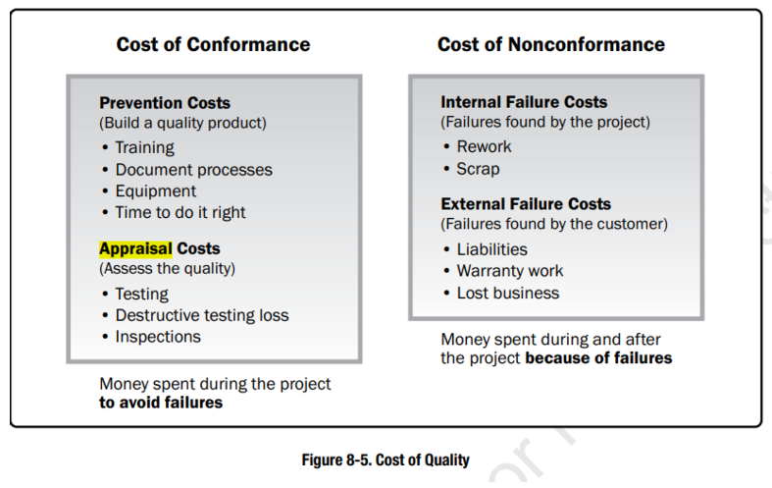
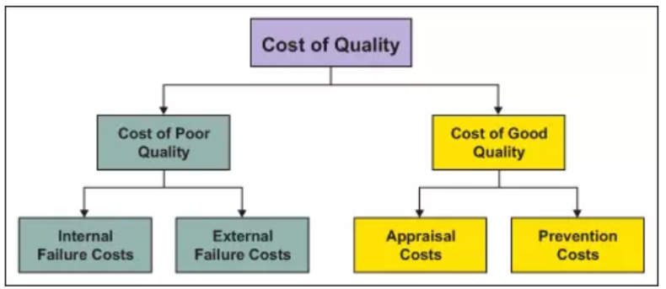
Solve:
- Prevention Costs (phòng ngừa cost)
  - Quality Training for Development Team
    - Description: Provide training on best coding practices, testing methods, and tools to minimize defects during development.
    - Estimation: 2 trainers for 2 days, each working 8 hours = 32 man-hours.
  - Developing Coding Standards and Guidelines
    - Description: Create and document coding standards to ensure consistency and reduce errors during development.
    - Estimation: 2 senior developers for 3 days, 6 hours/day = 36 man-hours.

Appraisal Costs (thẩm định cost)
  - Conducting Peer Code Reviews
    - Description: Developers review each other’s code to identify defects before testing begins.
    - Estimation: 4 developers, 2 hours per code review, reviewing 20 modules = 160 man-hours.
  - Test Case Development and Execution
    - Description: Create and execute test cases to validate functionality and catch defects during testing phases.
    - Estimation: 3 QA testers for 5 days, 8 hours/day = 120 man-hours.

External Failure Costs (hỏng hóc ngoài cost)
  - Resolving Defects in Production
    - Description: Fixing issues identified by users after the system is live, including root cause analysis and patch deployment.
    - Estimation: 2 developers and 1 QA tester, 5 hours per defect, resolving 10 defects = 150 man-hours.

Ex2: (SU24-RT) defines at least 5 quality assurance (QA) or quality control (QC) activities for the project. For each activity, you need to classify it to QA or QC + clearly describe the purpose, when, and how to do it.
Solve:

1. Develop and Enforce Coding Standards
- Classification: QA
- Purpose: Ensure consistency and minimize errors in code development by establishing clear standards.
- When: During the initial phase of the project and periodically reviewed throughout.
- How:
  - Define coding guidelines (naming conventions, structure, and commenting).
  - Conduct training sessions for developers.
  - Monitor compliance through automated tools (e.g., SonarQube).

2. Continuous Process Improvement Meetings
- Classification: QA
- Purpose: Evaluate and improve processes to enhance project quality and efficiency.
- When: Regularly throughout the project (e.g., sprint reviews or retrospectives).
- How:
  - Conduct team meetings to assess adherence to QA practices.
  - Identify bottlenecks, errors, or process issues.
  - Propose actionable improvements and track their implementation.

3. Conduct Peer Code Reviews
- Classification: QC
- Purpose: Detect defects and improve code quality early in the development cycle.
- When: After each feature/module is completed and before merging to the main branch.
- How:
  - Assign peers to review the code against the coding standards.
  - Use tools like GitHub or Bitbucket for pull request reviews.
  - Document findings and ensure corrections are made.

4. Automated Testing (Unit, Integration)
- Classification: QC
- Purpose: Validate individual units and their integration to ensure they meet functional requirements.
- When: Ongoing during development, triggered with each code commit.
- How:
  - Write unit tests (e.g., using JUnit for Java or pytest for Python).
  - Implement integration tests to verify module interaction.
  - Run tests automatically via CI/CD pipelines (e.g., Jenkins, GitLab).
5. Define and Execute Test Cases
- Classification: QA
- Purpose: Verify system functionality and ensure all requirements are met.
- When: During the testing phase, after development but before deployment.
- How:
  - Create detailed test cases based on requirements.
  - Execute tests manually or through automation.
  - Document results and retest after defects are fixed.

Ex3: (SU24-RT) Identify at least 4 project phases/iterations and 2 main deliverables in each phase/iteration. You need to provide the description for each of the identified deliverables about its content/purpose.

Solve:
Based on the provided project information, the project follows Agile methodology with a breakdown into iterations or sprints. Below are the 4 identified phases/iterations and the deliverables:

1. Phase: Foundation Setup (Weeks 1-2)
Purpose: Lay the groundwork for the project by setting up the project scope, environment, and architecture.
- Deliverable 1: Completed Backlog
  - Description: A detailed list of all features and tasks needed for the LMS project. This backlog serves as a roadmap for the development team during the subsequent sprints.
  - Purpose: Provide clarity on what needs to be delivered and prioritize work items for efficiency.
- Deliverable 2: System Architecture
  - Description: High-level design outlining the system components, their interactions, and technologies to be used.
  - Purpose: Ensure a clear blueprint for developers to build a scalable and efficient LMS.

2. Phase: Core Functionality Development (Weeks 3-6)
Purpose: Develop the fundamental features that enable basic functionality of the LMS.
- Deliverable 1: User Account Management Module
  - Description: Includes features like registration, login, user roles (admin, teacher, learner), and profile management.
  - Purpose: Provide a secure way for users to access and interact with the system.
- Deliverable 2: Course Creation Tools
  - Description: Tools for teachers to create courses, including lessons, quizzes, and other content.
  - Purpose: Empower teachers to generate educational material for learners.

3. Phase: User Interaction Features (Weeks 7-10)
Purpose: Enhance the user experience by focusing on learner-centric features.
- Deliverable 1: Course Browsing and Enrollment
  - Description: A polished interface for learners to browse, filter, and enroll in courses.
  - Purpose: Improve the accessibility of courses and streamline the enrollment process.
- Deliverable 2: System Testing and Feedback Integration
  - Description: Perform rigorous testing of the developed features and incorporate feedback from stakeholders.
  - Purpose: Ensure system stability and align functionality with user needs.

4. Phase: Deployment and Launch (Weeks 15-16)
Purpose: Finalize the system, conduct user acceptance testing (UAT), and launch the LMS platform.
- Deliverable 1: Deployed LMS Platform
  - Description: Fully functional LMS platform made live for all users, complete with core and advanced features.
  - Purpose: Allow learners, teachers, and admins to begin using the platform for educational purposes.
- Deliverable 2: Training Materials
  - Description: Documentation and tutorials for users (teachers and students) on how to use the LMS.
  - Purpose: Ensure smooth onboarding and effective use of the system.

Ex4: (SP24) Assume that you have defined and estimated the project schedule with the below high-level activities.
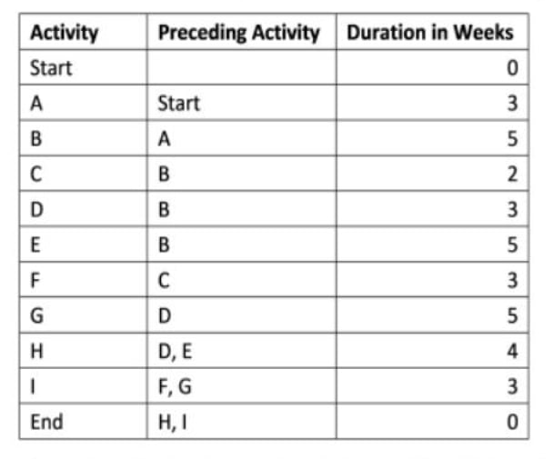
a) Use the critical path analysis technique to identify the minimum duration to complete this project
b) In the 8th week, you are executing activity B and find that you need to speed up the project schedule to recover the 3-week delay. Define 2 solutions with relevant explanations and assumptions (if needed) to achieve that (how it would help and difficulties/impacts to the project).

Solve:

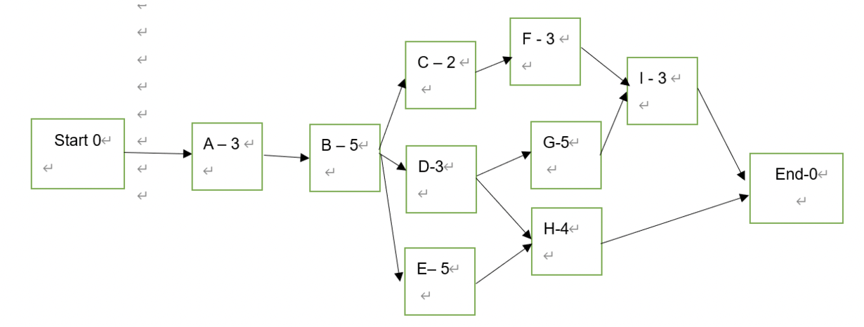Path 1: Start -> A -> B -> C -> F -> I -> End Duration 16 weeks
Path 2: Start -> A -> B -> D -> G -> I -> End Duration 19 weeks
Path 3: Start -> A -> B -> D -> H -> End Duration 15 weeks
Path 4: Start -> A -> B -> E -> H -> End duration 17 weeks
-> So the critical path is path 2 Start -> A -> B -> D -> G -> I -> End
The minimum duration to complete this project is 19 weeks.

Currently, the project is 3-weeks behind the schedule. In order to make a feasible plan to recover, I will shorten the project by 3 weeks compared to the planned schedule.
If you want to shorten the project time by 3 weeks which means the new duration of the project (assuming no delay) is 16 weeks, no path can exceed this number. First of all, when calculating the activity to decrease the duration, you have to consider firstly all the tasks in the critical path- the path that has the largest duration, but now 8 weeks have passed, (now you’re in task B and ), so we only have a way to shorten the time in task D, G, I. The appropriate choice is left with task G because a task with a duration of 5 weeks should be prioritized to shorten the time. So we will have a plan to shorten the task G from 5 weeks to only 2 weeks.
But after the critical path had been reduced to 16 weeks, Path 4 still exceeded this new duration (path 4’s duration is 17 weeks). Obviously, we have to reduce Path 4 by 1 weeks. Task E should be prioritized to reduce 1 week as it has the longer duration than task H.
Briefly, in order to reduce the project duration by 3 weeks, we have to shorten task G by 3 weeks and task E by 1 week.
Solution:
- Crashing method
- Solution 1: Add people to join the project to complete task G earlier than 3 weeks, and task E earlier than 1 weeks
- Solution 2 Force the team to work overtime on task G and E
- Solution 3 Reward the team if they can complete task G earlier than 3 weeks, task E earlier than 1 week
-> Crashing will increase the cost.
- Apply fast fast-tracking method
- Overlap task D and G. When we start the task D, we will start task G right away
- Overlap tasks E and H. After doing task E for 4 weeks, begin the task H.

Ex5: (SP24)
Your project team has completed a workload equivalent to $3,000 and has spent $4,000 to date. Assume that you were budgeted $5,000 for the work scheduled. At the start, the team had an estimated project budget of $9.000 and the project needed 12 months to finish. Calculate and give your calculations and comments on the project's current status, and the forecasts to complete the project in terms of cost and schedule.

Solve:
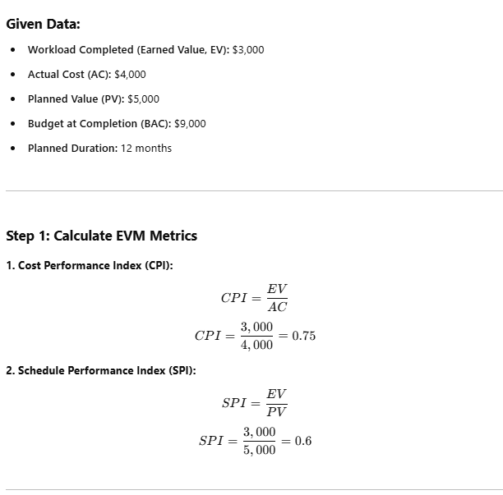
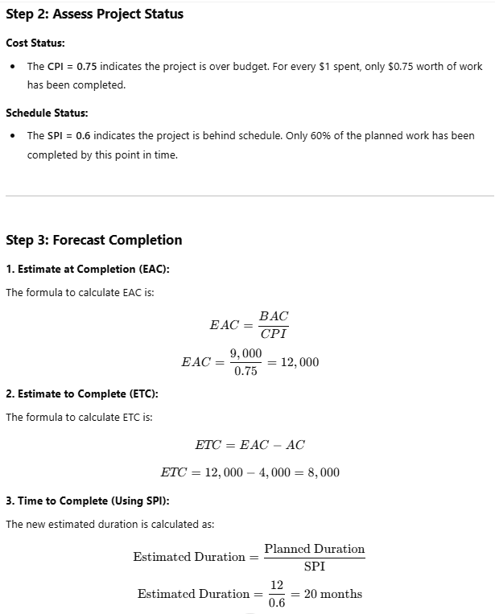
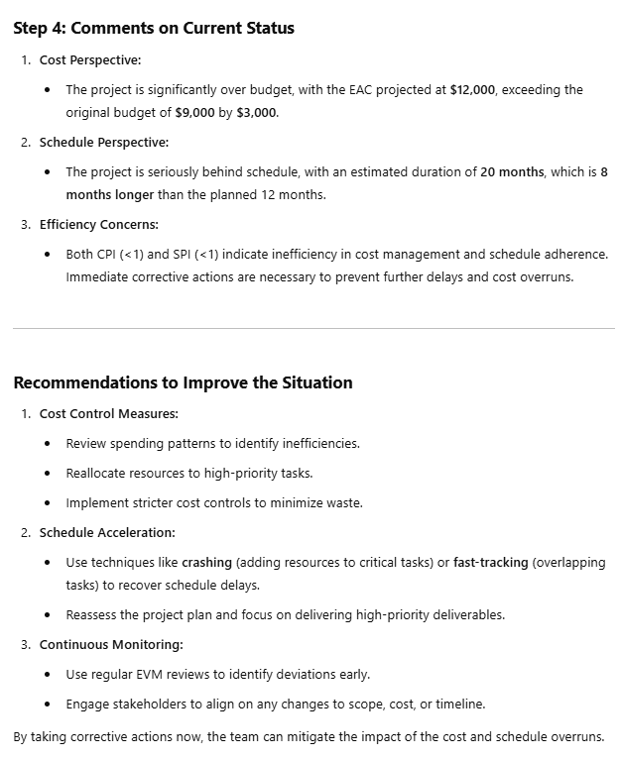

Ex6 (SP24-RT)
Given the following information for a one-year project 2 months after the project started, answer the below questions: PV (Planned Value)=$22,000; EV (Earned Value) $20,000; AC (Actual Cost) =$25,000; BAC (Budget At Completion) =$120,000
a) What are the cost and schedule performance of the project? Show your calculations.
b) How is the project doing in terms of project cost and time (schedule)? Explain those statuses
c) Use the CPI to calculate the estimate of the rest cost the team would need to complete the project.
d) Use the SPI to estimate how many months it will take the team to finish this project.

Solve:
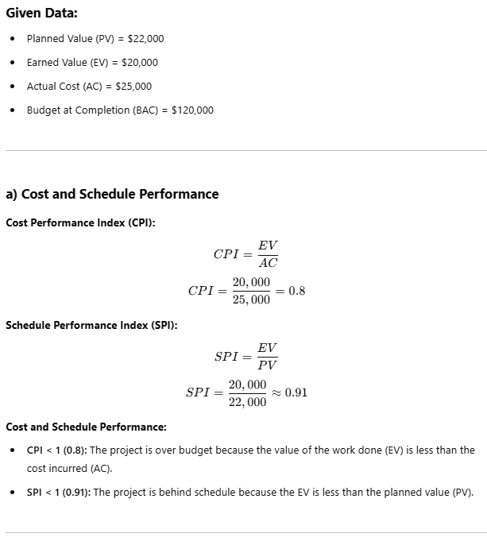
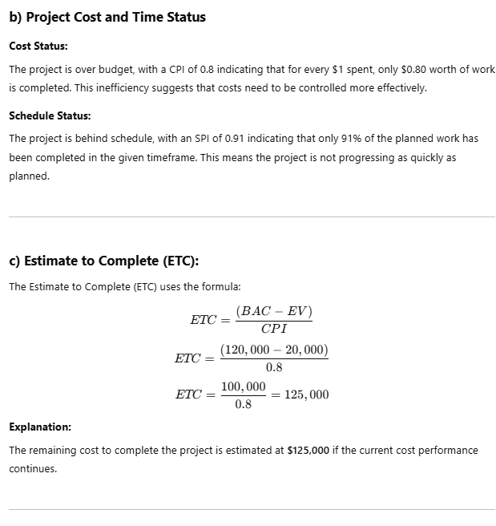
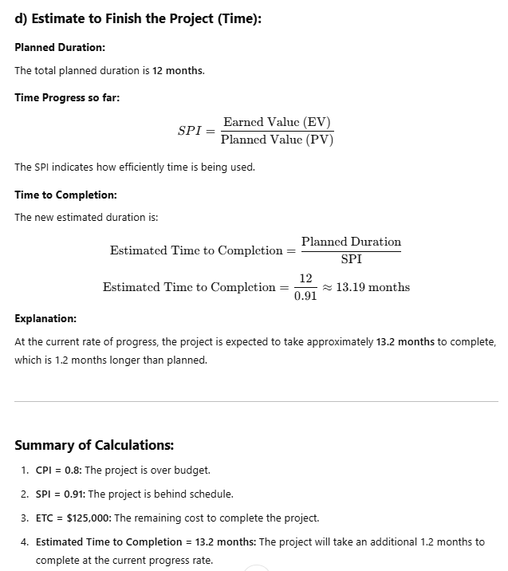

VI. Bonus
Ex1: Create Project Budget

Solve:

Project Budget
Total Budget: $30,000
Duration: 16 weeks (4 months)
Team Roles:
- 2 Backend Developers
- 1 Frontend Developer
- 1 Designer
- 1 Business Analyst
- 1 Tester
- 1 Project Manager

Cost Breakdown

1. Labor Costs (Based on average salaries and effort estimates):
- Backend Developers (2):
$10/hour x 2 devs x 20 hours/week x 16 weeks = $6,400
- Frontend Developer (1):
$10/hour x 20 hours/week x 16 weeks = $6,400
- Designer (1):
$7.5/hour x 15 hours/week x 16 weeks = $1,800
- Business Analyst (1):
$12.5/hour x 10 hours/week x 16 weeks = $2,000
- Tester (1):
$7.5/hour x 15 hours/week x 16 weeks = $1,800
- Project Manager (1):
$20/hour x 10 hours/week x 16 weeks = $3,200
Total Labor Cost: $21,600

2. Software and Tools:
- Design Tools (Figma): $75/month x 4 months = $400
- Testing Tools (Katalon): $70/month x 4 months = $280
- Project Management Tool (JIRA): $10/user/month x 7 users x 4 months = $280
Total Software and Tools Cost: $960

3. Infrastructure and Hosting:
- AWS Hosting Services:
$50/month x 4 months = $200
- SSL Certificate (Security):
One-time cost = $200
Total Infrastructure and Hosting Cost: $400

4. Training and Workshops:
- Agile Training for Team:
$200/session x 2 sessions = $400
- System Usage Workshops for Teachers and Admins:
$300/session x 3 sessions = $900
Total Training and Workshops Cost: $1,300

5. Miscellaneous:
- Contingency Buffer (10% of Total Budget): $3,000

Final Budget Summary:
Category | Cost
Labor Costs | $21,600
Software and Tools | $960
Infrastructure and Hosting | $400
Training and Workshops | $1,300
Contingency Buffer | $3,000
Total | $27,260

Ex2: Earn Value Management:

Solve:

